1. The CO2 time series is plotted in figure 1. The series appears to oscillate with regularity around a positive trend line.

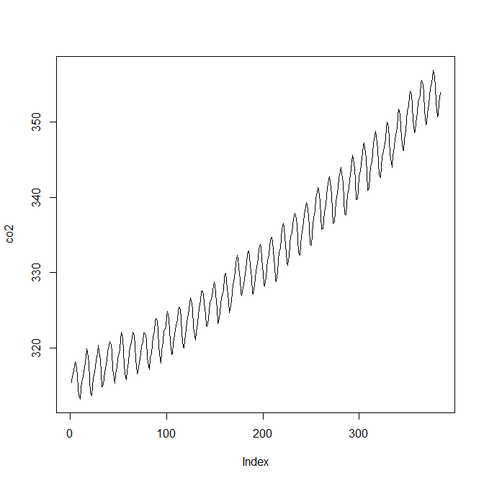

Figure - CO2 Time Series Plot

The linear and quadratic trend components were removed. The de-trended time series is shown in figure 2.

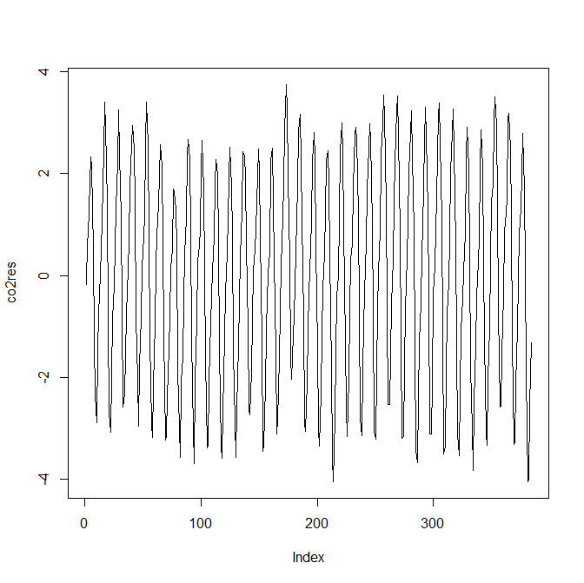

Figure - De-trended CO2 Series

The periodogram was computed. The DC component and components with frequency above pi were omitted. The periodogram is shown in Figure 3. The log periodogram is shown in Figure 4. The log periodogram is more informative because it shows the fine details, including additional harmonics which were not apparent from the periodogram. The dominant frequencies occurred at indices 32, 64, 96, and 128. 32/384 reduces to 1/12 which makes sense since the data is monthly. This indicates a strong cyclical component with a period of 12 months. The peaks at 64, 96, and 128 are harmonics of this fundamental frequency. This is in agreement with the time domain plot of the series, which shows a strong cyclical component.

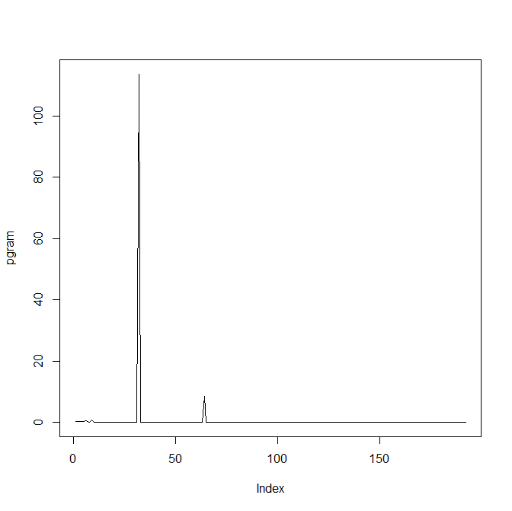

Figure - CO2 Periodogram

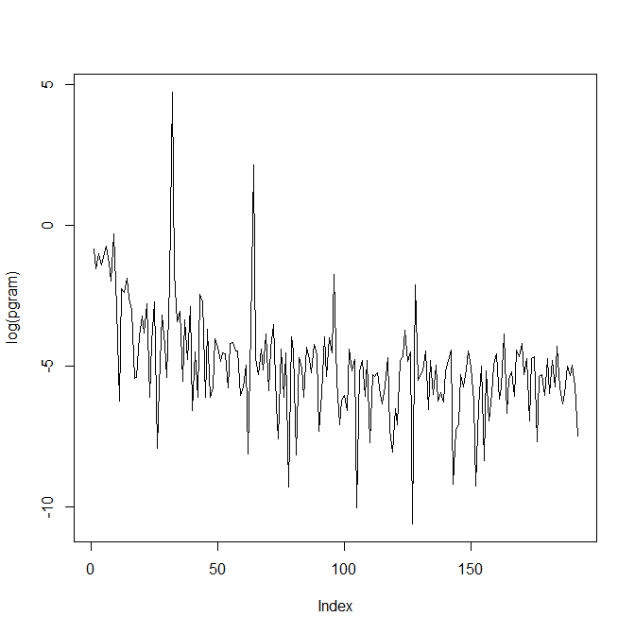

Figure - CO2 Log Periodogram